Maharati Comments 13-08-2026

Landing / Opening Page:
- Maharati Logo does not appear
- Project’s logos should appear, at least on the landing page

Log-in:
- it’s better to have a guest mood so that the user can access the application then it can request registration before using features that needs his/her info.

Backend:
- Can we check and test the backend and the dashboards generated in the backend?

General/ Overall Comments:
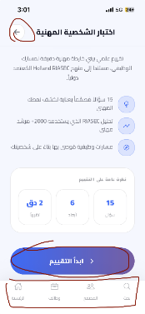
- Direction of text and arrows: Direction of text and arrows seem to be from left to right, but should be from right to left e.g. The arrows for moving forward point to the right, and the arrows for moving backwards point to the left, while it should be the opposite. Also, the menu bar should be reversed to be: Main Menu, Jobs, Community then search. It seems like all navigation is copied from an English version and is thus very counterintuitive in the Arabic one. Please see the screenshot on the right (Please Zoom in to see the screen)

- Languages: We need the App to run in Arabic and English. So far, it is only in Arabic.
- Logging-out: The app keeps logging out. Not sure if this is something because it is a test version or if it’s something that needs to be fixed.
- Accessibility Features: What are the accessibility features in the app? We added those in the previous version and should be maintained in the new version as well.
- Side-bar Icon: I think the side bar icon should always appear. Currently, it only appears on the main page, but if the user chooses one of the modules from the sidebar, he has to go back to the main page and choose another module or return to the sidebar, which I think defeats the purpose of having a side-bar.

تقييم الذات:
- When the user chooses an answer to any of the questions, the transition is a bit abrupt showing a flashing screen that is distracting to the user.
- After displaying the results, I remember in iCareer’s presentation saying the app will go a step further to link the profile with existing jobs that could fit the personality type. Please confirm if this will still be developed.
In other words, the results of the assessment should be leading to the career pages and vacancies in the app matching the user profile.

منشئ السيرة الذاتية:
- This module, had two features in the old version: 1) CV Builder 2) Cover Letter Builder. In the current version, it’s only a CV builder. I think we need the cover letter builder as well as it gives tips on how to write a good cover letter and the format that should be followed.
- When clicking "استمع للشرح" nothing happens across all pages. It’s important to have these tips to guide the users.
- In the previous version, there were tips that the user can read or listen to for filling each field. I believe these would be beneficial if added in the new version as well to guide users.
- Since users are already registered, can we have some of the fields, like the name for instance, read automatically from the registered info while also giving them the option to edit if they need to?
- When choosing the type of CV, there was a feature in the original version asking the user a couple of questions if they do not know which type of CV to choose from and based on their answers, they would redirect them. For some reason this is not available in this version, although I think it was a useful one.
- To minimize errors, some fields should only accept certain formats and provide an explanatory error message e.g. phone, date e-mail address.

فرص عمل:
- Clicking the search bar does not do anything, the user cannot even type a search term.
- Clicking any of the 3 sites merely redirects the user to the websites of Shaghalni, Wuzzuf and Forasna. As discussed it would be better that the vacancies display directly in the app and the user can apply from it directly. And not to need to log in again to the websites.
- Shaghalni: Website is incorrect. It should be shaghalni.com not shaghlni.com (There is an “a” missing in the name)
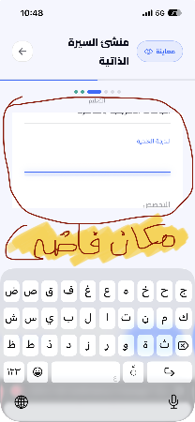
- There is a substantial blank space between the editable screen and the keyboard. I think the editable screen needs to be bigger for a better view and better navigation. (Please check the screenshot on the right)
- Switching from the editing mode to the navigation mode does not always come naturally. Perhaps we can add an icon that hides the keyboard to resolve this.
- When trying to add a new skill, pressing "إضافة" does not do anything.
- When trying to add a new certificate, pressing "إضافة شهادة" does not do anything.
- When trying to add a new language, pressing "إضافة " does not do anything.
- After finishing the CV, the share button is not working. We should have the below options after finishing the CV: 1) edit 2) share 3) save as PDF 4) save as a Word Document.

محاكاة المقابلة:
- I really like the AI feature, I think it has the potential of being very useful and much more user-friendly than the previously used VR feature.
- With that being said, we need to understand what is the model being used and the data privacy policies and regulations. These should be clear to the users as well.
- I tried giving it an irrelevant answer when answering different the question about strengths and the evaluation was more than 60% in most of the times! Additionally, sometimes it gives the same feedback even if not true. I think the model need to be better trained somehow or have a different model if feasible?
- There was an instructional video giving useful tips on how to prepare for an interview. I think we should keep the video in the new version as well.

مجتمع مهاراتي:
- The module does not have many options except adding a post. I think it needs to enable users to browse or search by topics for instance and be organized better somehow rather than just having posts listed ion a chronological order.
- The user should also be able to edit or delete his/ her post.

موارد للتطوير:
- I was not really able to test this module as it did not have enough content I think. Perhaps would be better tested in the upcoming iteration.
- This directs to different screen when clicked from the sidebar and when clicked from the main menu and both are not really clear to me how they would function. In all cases, I think they need to be unified.

قيمنا:
- Clicking on this icon in the sidebar menu does not do anything.

Search:
- It’s not very clear to me what the search feature will do, how it functions and where does it search.

Surveys:
- We had a feature where we can publish a customized survey from the backend. I think it would be useful to keep this feature.

